**Simplified Inbound Logistics**

**Know more section**

What does the digital supply chain mean for your company? More integration, better visibility, lesser human errors and higher accuracy.

Inbound logistics is a vital part of the supply chain which involves procuring material from various vendors. Implementation of digital improvement strategies in Inbound logistics is critical to the success of modern business landscape.

**Simplified Inbound Logistics Key features**

Inbound logistics process can be simplified by integration sensors, Bar code scanners or QR Code scanners with ERP systems.

As an example, consider the process of Gate entry in a factory – Gate entry involves the security guard at the gate making the entry of the truck in the factory. This is to be followed by the weighing of the goods on a weigh bridge.

Below is an example of using Simplified inbound logistics in Gate entry ,Weighing, Goods Receipt and Quality check process process

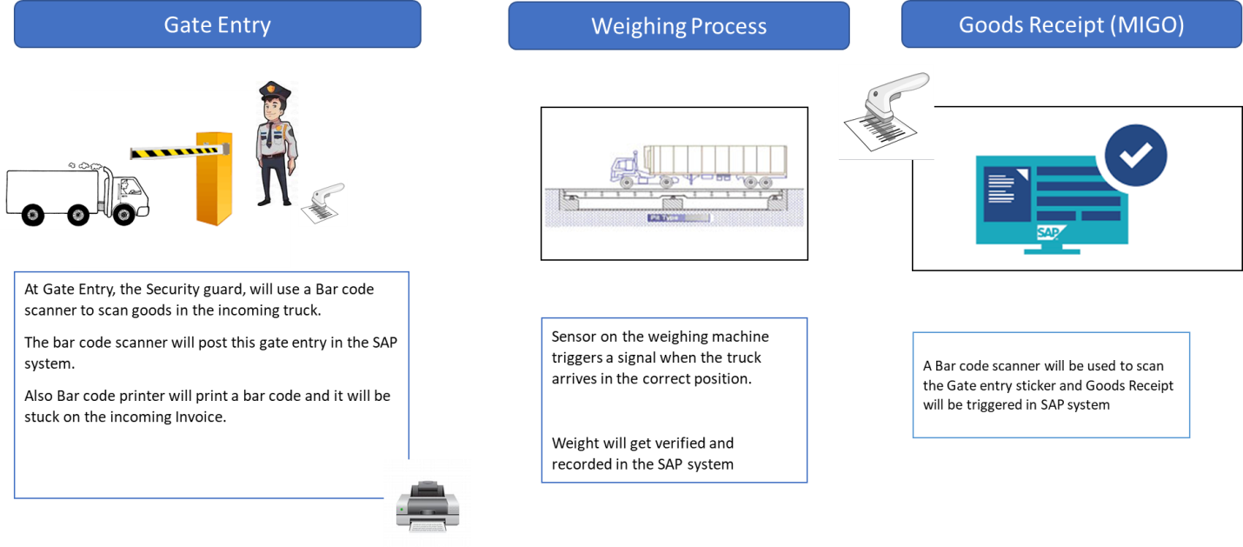

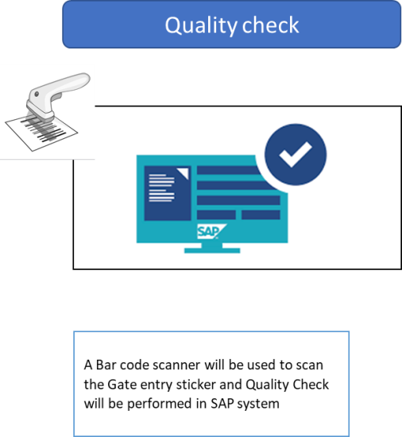

Thus we see that by using digital tools and methods, the process has been simplified and has also resulted in significant saving of man hours.

Other processes which can be automated are Incoming POs, MIGO etc.

**Benefits of Simplified Inbound**

* Cost reduction
* Accurate tracking of goods
* Precision
* Reduced turnaround time
* Reduced cost
* Reduced man hours
* Higher efficiency
* Reduction in lead time
* Lean Inventory

**Industry Coverage –**

Different industries have different processes for their inbound logistics and therefore will have different needs. Digizura will offer services for Rapid Outbound across various industries, few of which are mentioned below

* Automobiles
* Consumer goods
* Manufacturing
* Mining
* Cables
* Steel